**VRIO Analysis**

Report for Human Resources

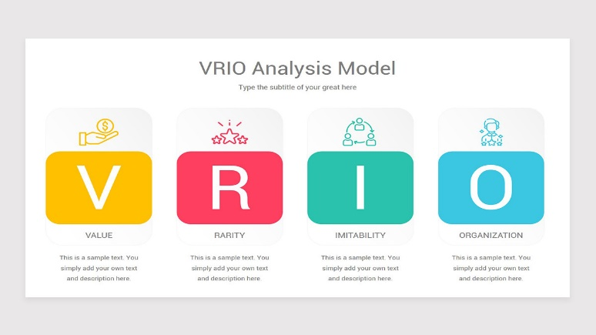

**Data Driven Decision Making**



**Data Dynamos**

For HR Data Analysis

**VRIO Analysis Report for Human Resources**

**1. Introduction**

This report aims to analyze the company's resources using the **VRIO** framework, which helps in identifying sustainable competitive advantages. The analysis is based on available data regarding job performance, education, training, job satisfaction, and organizational stability.

**2. VRIO Analysis**

**There are some general ratios that have been estimated roughly, closer to reality, due to their absence in the analyzed data**

**First: Value**

The value of human resources is determined by several factors, including:

* **Percentage of high-performing employees.**
* **Percentage of employees who received professional training.**
* **Percentage of employees with a good work-life balance.**
* **Employee satisfaction with the work environment.**
* **Impact of training opportunities on performance improvement.**

✅ **Conclusion:** The company's human resources are highly valuable due to strong investment in training and high job satisfaction, which positively reflects on overall company performance.

**Second: Rarity**

The rarity of human resources is determined based on:

* **Percentage of employees with higher education (Master’s or PhD):** **30.3%**



* **Percentage of employees with advanced technical skills.**
* **Percentage of employees proficient in more than one language.**

✅ **Conclusion:** Although the percentage of employees with higher education is not very high, it provides the company with an advantage in certain specialized fields. Additionally, the presence of employees with advanced skills and multilingual capabilities enhances competitiveness.

**Third: Imitability**

* **Percentage of employees who received professional training.**
* **Percentage of high-performing employees.**
* **Company’s investment in building a continuous learning culture.**
* **Presence of unique and distinguished internal training programs:** **Yes**

✅ **Conclusion:** The company’s investment in skill development and training programs makes it difficult for competitors to replicate this advantage easily, especially with a strong learning culture and distinctive training programs in place.

**Fourth: Organization**

* 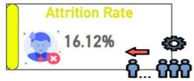**Employee attrition rate:** **16.1%**
* **Percentage of employees with a good work-life balance.**
* **Stability of teams and leadership roles:** **80.6%**
* **Effectiveness of HR strategies in talent retention:** **84.9%**

✅ **Conclusion:** These figures indicate a well-structured organizational environment that helps retain employees and reduces turnover rates. Additionally, the effectiveness of HR strategies enhances organizational sustainability.

**3. Recommendations**

**✅ Enhance training and professional development programs** to maintain a competitive edge in skills and performance.

**✅ Increase recruitment of rare and highly qualified talents** to raise the percentage of employees with higher education and advanced technical skills.

**✅** **Analyze the causes of employee turnover and work on reducing it** by improving the work environment and increasing job incentives.

**✅ Invest in the development of internal training programs** to create a dynamic learning environment that strengthens in-house expertise.

**✅** **Strengthen organizational strategies to maintain job stability** by empowering effective leadership and improving career development plans.

**4. Conclusion**

Based on the **VRIO** analysis, the company possesses valuable and somewhat rare human resources, with difficulty in imitation due to strong training and development strategies. However, this advantage can be further enhanced by improving education and training, strengthening talent retention strategies, and reducing turnover rates to sustain competitive superiority. Additionally, focusing on developing a more stable organizational environment will enhance the sustainability of the company's competitive advantages.



|  |
| --- |
| **Data Dynamos** |